One Page Biodata
- General Information
Name | Mrs. Suryavanshi Arti Prashant |  |  |  |  | 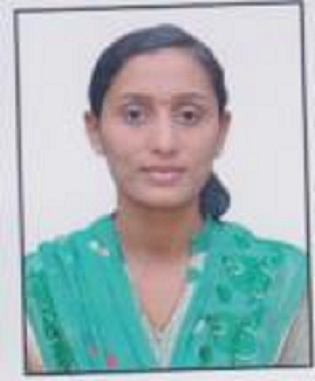
Designation | Assistant Professor
Department | Computer Engineering
Qualification | PhD- Appeared
 | M.E-CSE
 | B.E.- CSE
Date of Joining | 2/08/2017
Experience | Total |  | Teaching |  |  | Industry
 | 4.6 Years |  | 4 Years |  |  | 2.6 Year
Area of Interest | Cloud Computing, Secury, Networking
Contact Details | Email |  |  |  | Mobile/Phone
 | artips15@gmail.com |  |  |  | +91 7588600744  +91 9975238623
Research Publications | International Journals | National Journals |  |  | International Conferences |  | National Conferences
 |  | Nil |  |  | 03 |  | 03
Workshops | Attended | 04 |  |  | Organized |  | Nil
FDP | Attended | 01
Professional Memberships | Name |  |  | Membership No.
 | IAENG- Member |  |  | 235524
 | IRED- Member |  |  | AM101000583627

- Academics
Subjects Taught: | Data mining, Principle Of Programming Language, System Programming and Operating System, Digital Electronics and Logic Design, Information Security and Economics Engineering, Artificial Intelligence and Robotics.
- Departmental Portfolio
Portfolio Name | Activities Done
NAAC | Departmental Criteria -II Coordinator
Class Coordinator | - Preparation of Attendance Sheet  - Preparation of Mentor List  - Student Record  - Interaction with Parents  - Result Analysis
Project Guide | - Image Authentication using Stochastic Diffusion In IJERT, Volume. 4, Issue. 04 , April – 2015.  - Implementation of Cloud Deduplication Mechanism Using Sentence Based Chunking On Hybrid Cloud Architecture  Volume 5 Issue 7, July 2017 in  International Journal of Scientific Engineering and Research (IJSER)  - Survey on Data Deduplication of Text File over Cloud. has been published in Volume 6 Issue 1, January 2017 in International Journal of Science and Research (IJSR)
- College Level Portfolio
Portfolio Name | Activities Done
PARAS- 2K18 | College of Engineering Coordinator
Udaan 2K19 | Cultural Committee
- Personal Details
Date of Birth | 23rd June 1986
Gender | Female
Nationality | Indian
Marital Status | Married
Permanent Address | Parikrama Staff Quarters, Room No-203 A/P- Kashti, Tal- Shrigonda, Dist- A’Nagar.

